Impact AssessmenT
- SSCC & SAYDET EL ZALZALE

FREE energy
www.freeenergy.co
August 17, 2022

Contents
Contents 1
SSCC – PV System Installation 2
Existing Situation: 2
Comparison with 2019 Bills 3
Financial Impact 5
Environmental Impact: 5
Saydet Al Zalzale –Battery Bank Installtion 6
Existing Situation 6
Financial Savings 7

SSCC – PV System Installation

Existing Situation:
The PV system installed at SSCC is a 92.22 kWp PV-Diesel On Grid System, which means that the system is operational with both EDZ and the private generator owned by the school. This report aims to display the impact of this system on the school's electrical consumption from EDZ, which will, in turn, affect the electrical bills paid by the school.
The PV system became fully operational on June 12, 2022, and has been delivering electrical energy to the school since then. The electricity produced by the PV system can be monitored and recorded on a platform specific to the inverters used..

Month | Production
From June 23 | 3.33 MWh
July | 12.50 MWh
Until August 11 | 3.38 MWh
Total | 19.21 MWh

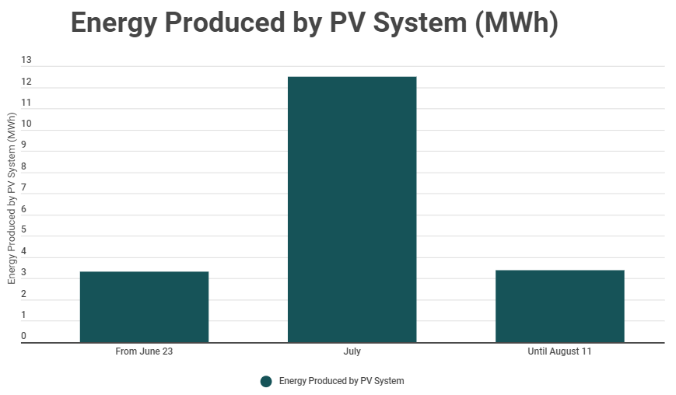

Comparison with 2019 Bills
For comparison purposes, the Electric Consumption of the facility during the abovementioned months can be obtained from the 2019 bills. The year 2019 was chosen since it accurately demonstrates the facility's operation before the Covid-19 pandemic and the economic crisis. The total electrical consumption of the facility is displayed below:
Bills 2019 | Total Consumption (in MWh)
19-Jun | 15.44 MWh
19-Jul | 12.07 MWh
19-Aug | 10.32 MWh

The only complete month recorded by the monitoring system is July, so to compare the remaining two months, the electrical energy produced by the PV system was extrapolated. The extrapolation was made by finding the average electrical energy produced per day based on the recorded information and multiplying this number by the number of days per month.
June
From June 23 | 3.33 MWh
Days of Production | 8 Days
Production per Day | 0.42 MWh/Day
Number of Days per month | 30 Days
Estimated Production for June | 12.49 MWh
August
Until August 11 |  | 3.38 MWh
Days of Production |  | 11 Days
Production per Day |  | 0.31 MWh/Day
Number of Days per month |  | 31 Days
Estimated Production for August |  | 9.53 MWh

Comparison Table
Month | Consumption Based on 2019 Bills | Production | Percentage Covered
June | 15.44 MWh | 12.49 MWh | 81%
July | 12.07 MWh | 12.50 MWh | 104%
August | 10.32 MWh | 9.53 MWh | 92%
Total | 37.84 MWh | 34.51 MWh | 91%
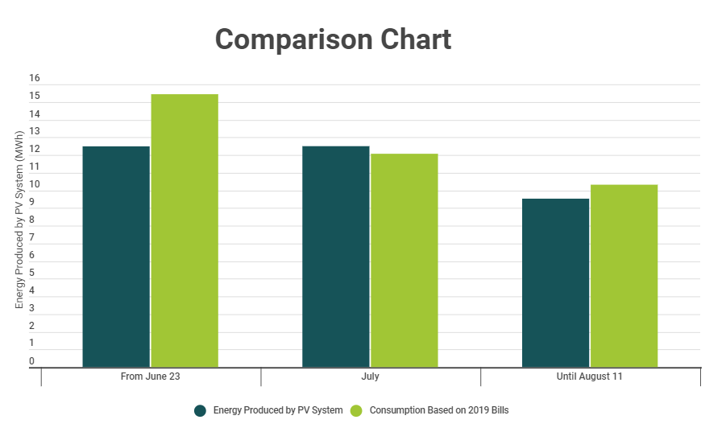
Based on the above table and graph, the system can cover 91% of the facility's electrical consumption. However, it is important to note that in July, the production exceeded the expected consumption by approximately 4%, this excess energy produced is recorded by the smart meter installed by EDZ and is used at a later stage when the consumption exceeds the production..

Financial Impact
The total energy produced by the PV system till this date is 19.3 MWh, the adopted LCOE for this analysis is 0.35 $/kWh. By multiplying the total energy produced by the unit cost of energy, the total savings of the system till this date are obtained.
Month | Production | Savings
From June 23 | 3.33 MWh | $ 1,165.50
July | 12.50 MWh | $ 4,375.00
Until August 11 | 3.38 MWh | $ 1,183.00
Total | 19.21 MWh | $ 6,723.50

Environmental Impact:
The installed solar system is estimated to generate significant environmental benefits. These benefits come primarily from avoided power plant emissions. Below is a representation of the lower carbon footprint in several reduction equivalents obtained to this date:

10.23 Tons  of CO2 Saved | 262 Acres  of Plants Planted | 41,048 km  Traveled

Saydet Al Zalzale –Battery Bank Installtion

Existing Situation
The battery bank system installed at Saydet el Zalzale is a 7.7 kWh Lithium-Ion Battery System. This system was installed to permit the facility to operate normally during EDZ's cut-off hours. However, the facility can still benefit from the PV system by installing a battery bank even though EDZ is off. This, in turn, improves the system's performance and increases its yield knowing that the two cut-offs during the day are at peak sun hours. Furthermore, in most cases, the battery bank during the day is not discharging and recharging since the electrical energy directly produced by the solar system is enough to sustain the load. The below graph displays the information stated above.
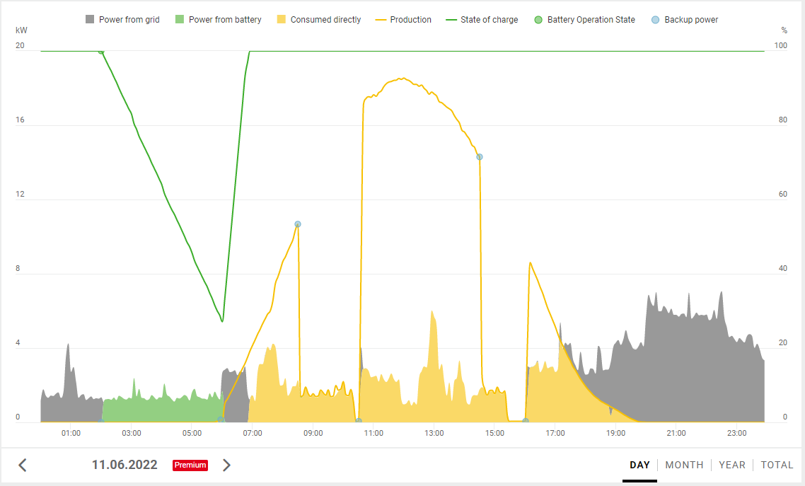

Financial Savings
As mentioned earlier, the battery system allowed the PV system in the facility to operate without the need for EDZ and allowed several hours of autonomy to sustain the facility during cut-offs. The production without meters from May, when the battery bank was implemented, is 2.36 MWh.

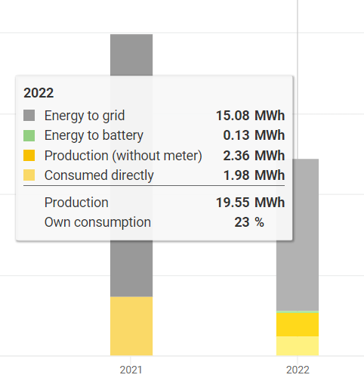
The savings, in this case, can be obtained by comparing the cost of producing this energy using a diesel generator. To do so, a conversion factor of 2.6 kWh/L was taken to convert the energy produced to liters of diesel. As a result, the average diesel price during this period was 33,000 LBP/L, equivalent to approximately 1.14 $/L.
Energy (without meter) | 2,360.0 kWh
Conversion Factor | 2.60 kWh/L
Liters of Diesel | 907.69 L
Unit Price of Diesel | 1.14 $/L
Total Savings | $ 1,034.77

Solarweb.com
A net metering subscription with EDZ was made to allow for this process to happen.
Levelized Cost of Energy: Cost ($) per Energy Consumed (kWh)
Production without meter

